Tanmay Fadnavis

SUID: 971141760

Computer Security

Lab-2

# TASK 1: EXPLOITING THE VULNERABILITY

The screen shot for task1 are below.

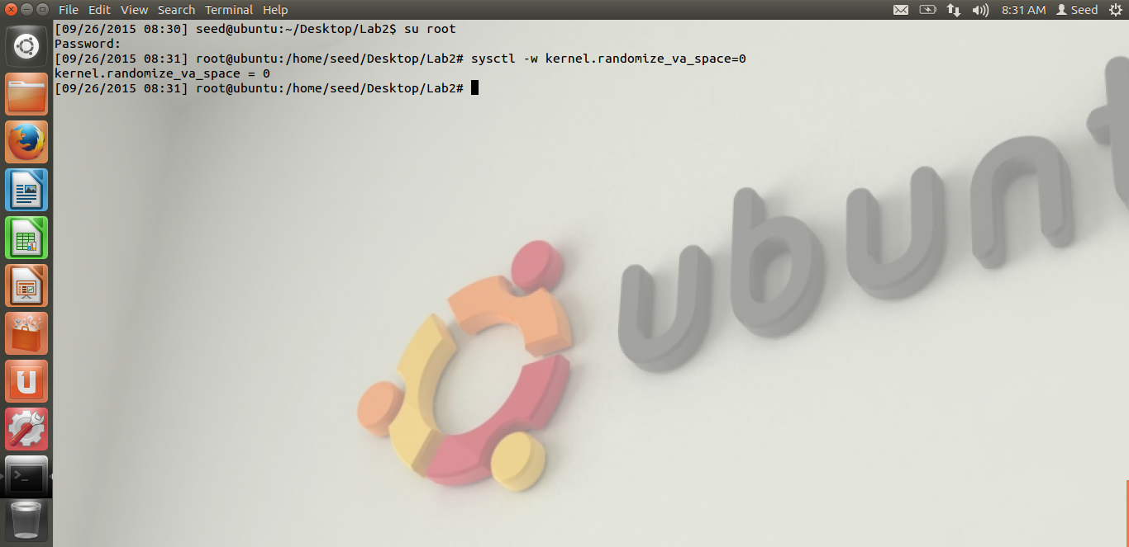

Lab set-up. In the above screen shot, we can see that we have disabled address randomization.

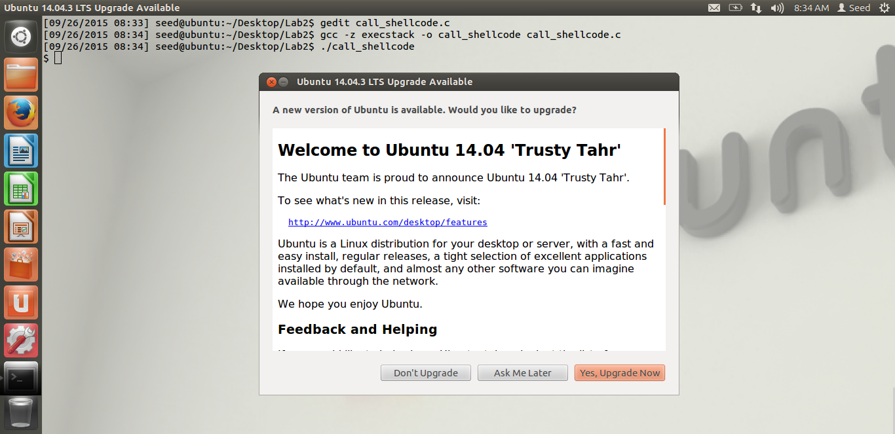

When we execute Dr. Du’s code, call_shellcode, we get the user shell as seen above.

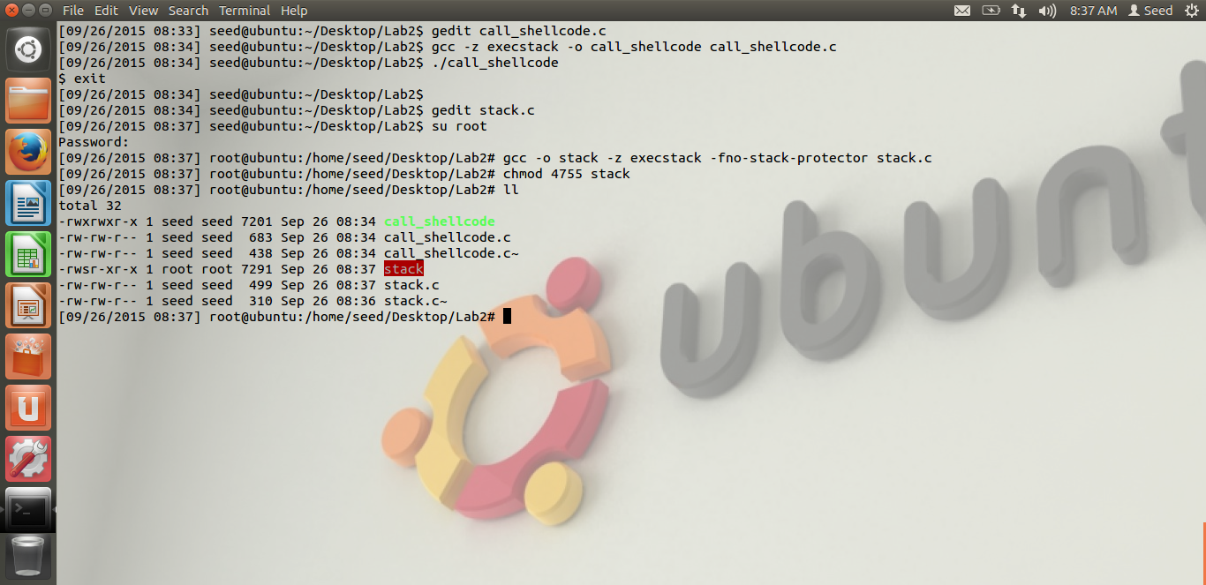

From the above screen shot, we see that we have compiled the vulnerable program, stack.c given by Dr Du. While compiling, we have made the stack executable and we have disabled the stack guard protection. After compiling, we have made the owner as root, and we have made it a set-UID program. We can see that from the red color of the stack executable file. Thus, the environment set-up for the first task is complete.

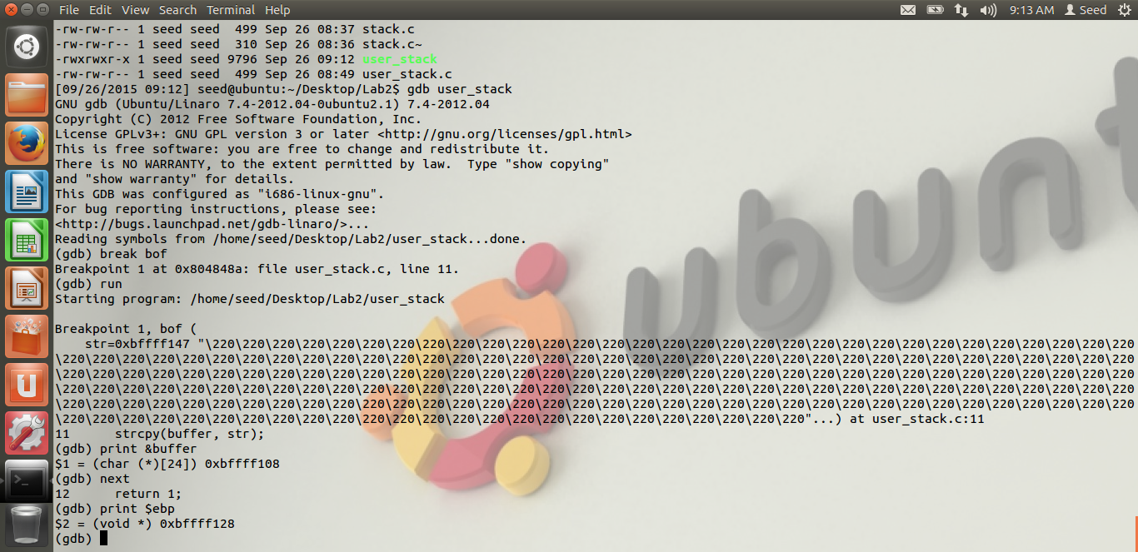

After that, I have made a copy of the vulnerable program, i.e. user_stack for debugging purpose.

After we run the gdb debugger on the user_stack, we can see from the screen shot, that we get the value of the buffer array, i.e. the starting value of the buffer array, by running the command “print &buffer”. The value in my case is “0XBFFFF108”. We also get the value of the ebp, by running the command “print $ebp”. The value in my case is “0XBFFFF128”.

I will explain the output first, later I will explain my return address and the address of the vulnerable code.

The exploit program is as below.

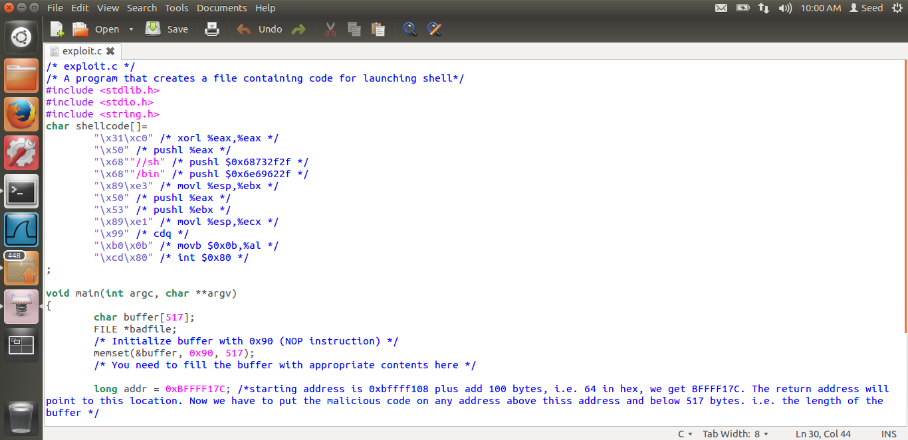

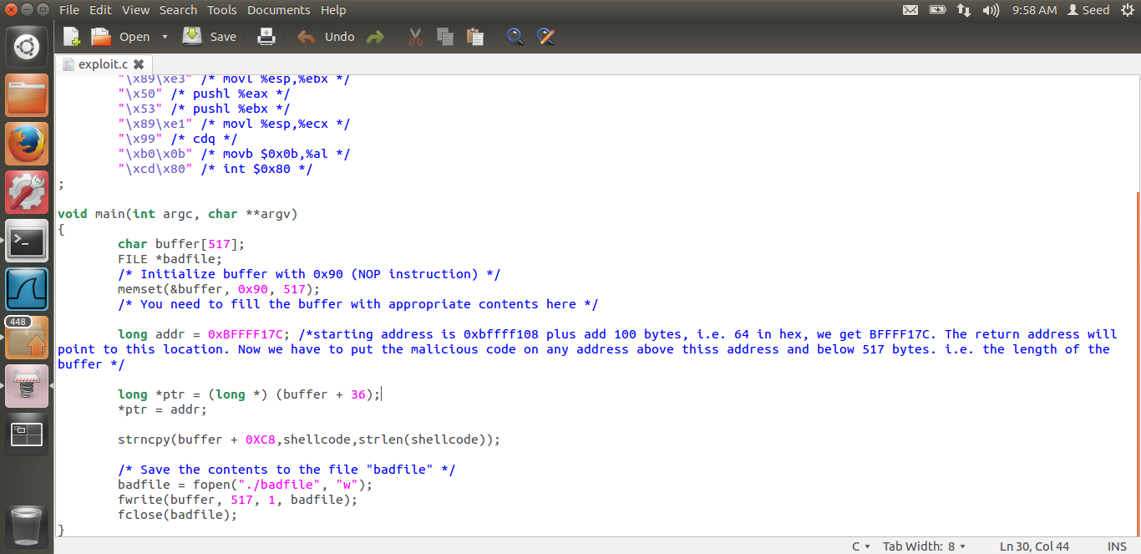

The address where I have my return address pointing to is 0Xbffff17c.

In the buffer, my return address is at the address (buffer + 36), i.e. 36 bytes from the beginning of buffer. The explanation is as below with the help of a diagram of the stack.

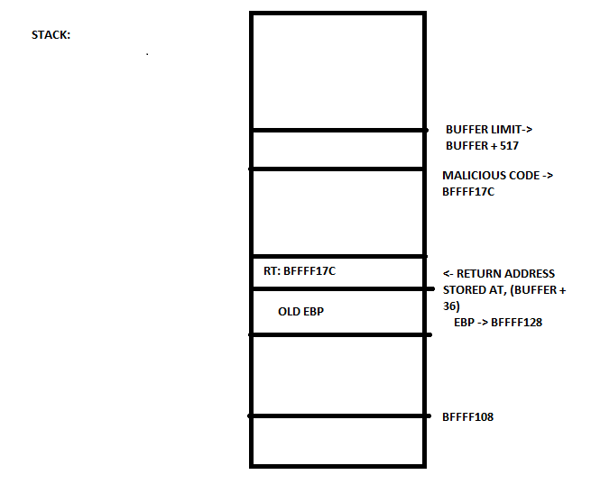

So, from the gdb, we get the buffer starting address is 0xbffff108, and the ebp pointing to address at 0xbffff128. But this address is in hex. And 4 bytes above ebp will be used to store the Old ebp. The 4 bytes above it will be used to store the return address. Here we need to put the address of our malicious code. But in the code which Dr. Du has provided below,

long addr = 0xFFEEDD88;

long *ptr = (long *) (buffer + i);

*ptr = addr;

The i variable is decimal, means how many bytes from the buffer starting address, the return address will be there. If we do the hex subtraction, we get 32 in decimal, between the buffer starting address and the ebp, i.e. 32 bytes of buffer. Plus 4 bytes will be used to store the old ebp. Hence we need to store return address at ( buffer + 36). Hence in the exploit code, we have stored the return address at (buffer + 36). Once this is done, we need to copy our malicious code given by Dr. Du and store its address in the return address.

In my exploit program, the address stored in return address location is “0Xbffff17c”. Thus the return address will point to the address which is 100 bytes from the starting location. As we are filling the buffer with NOP instructions, once the return pointer goes to 100 bytes above buffer, if our malicious code is present anywhere after those 100 bytes, and before the 517 bytes, because our buffer is 517 bytes, then that code will be executed eventually.

Now, once we point the return address to 100 bytes from the buffer, the malicious code must be put. In the exploit.c program, I am putting the malicious code at the address (buffer + 0Xc8), I.E. 200 bytes from the start of the buffer. So, once we put our malicious code there, the return address will point to the address 100 bytes from the start of the buffer, then due to NOP instructions, it will reach the malicious code, and we will get the root shell.

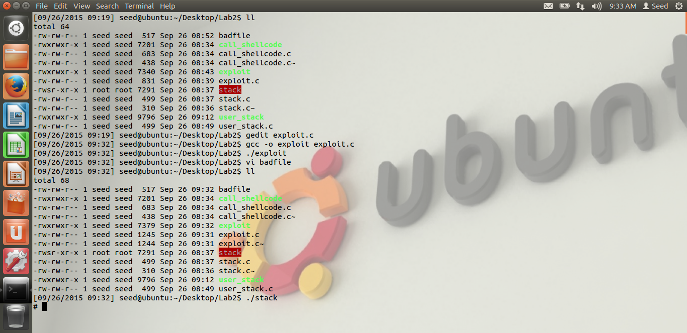

Thus, we can see that, when we run the set-UID stack program, we are successfully getting the root shell. Hence the attack is successful. The exploit.c program generates the badfile. The hex dump of the bad file is below.

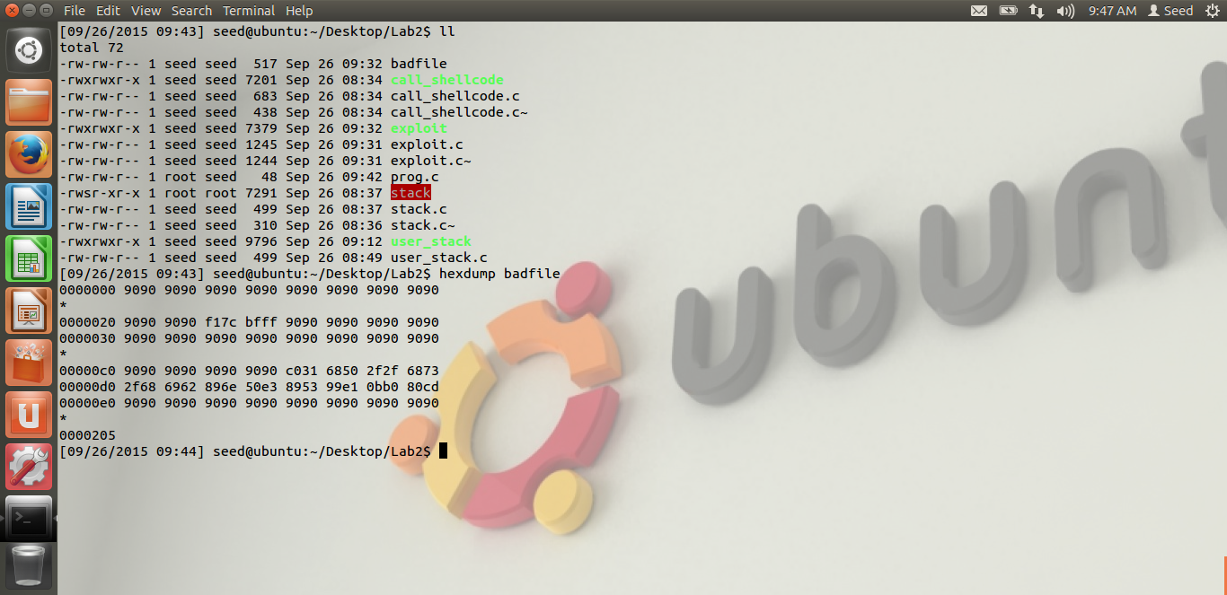

Thus, from the hex dump, we can see the address location at the return address, and the hex code of the malicious code given by Dr. Du.

Once the attack is successful, the real user-id is still seed.

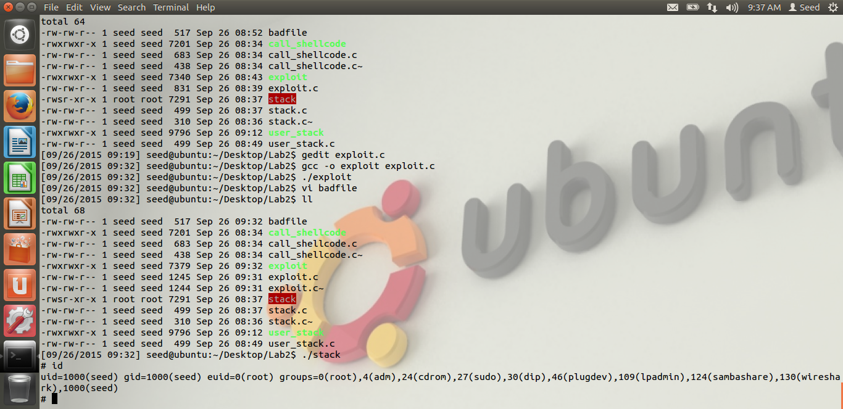

We can see that, when we run the ID command, the uid=1000, i.e. seed and the effective id is root (euid=0). To solve this problem, once we get the root shell, we execute the code given by Dr. Du. The below screen shot shows that. We have compiled Dr. Du’s code in prog.c. Once we execute it, the ID will become root.

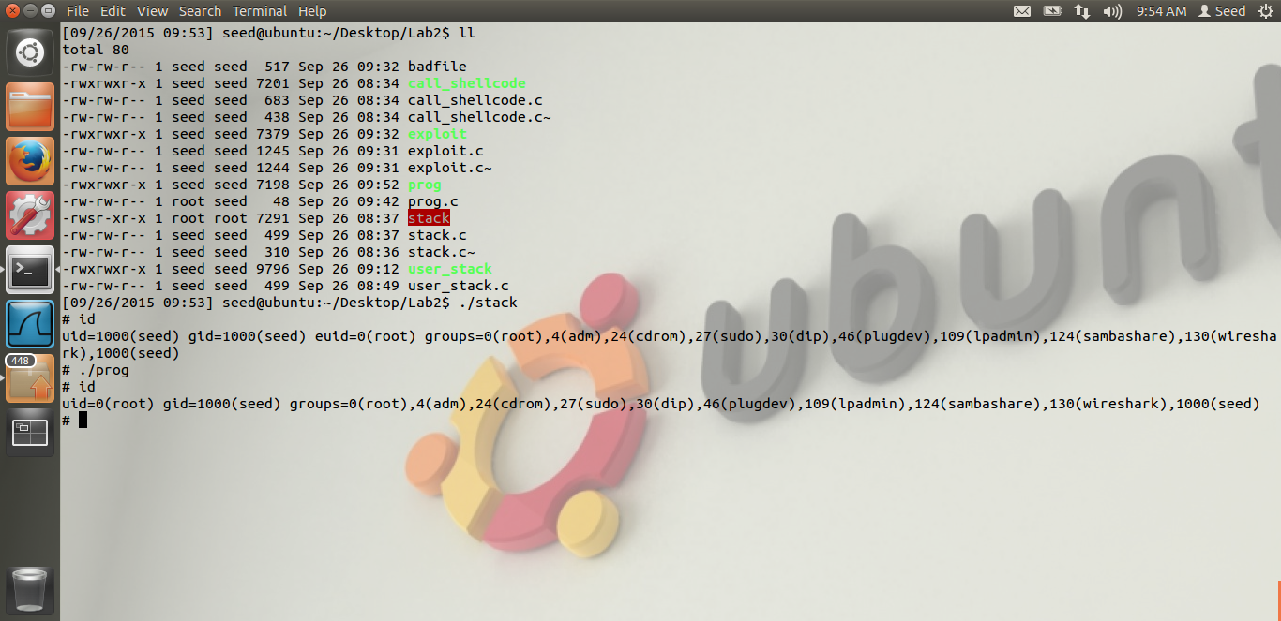

Thus, after executing the code, when we run the id command, we get the uid=0(root) as seen from the screen shot.

Thus, we have successfully exploited the vulnerability and completed the buffer overflow attack.

# TASK 2: ADDRESS RANDOMIZATION

The screen shot for Task2 are below.

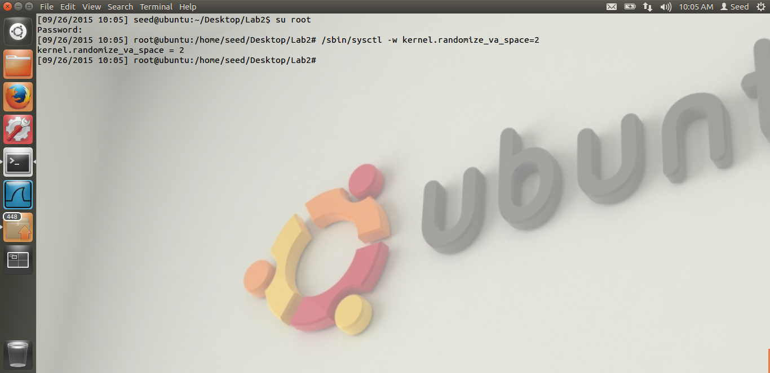

In the above screen shot, we have turned on the address randomization.

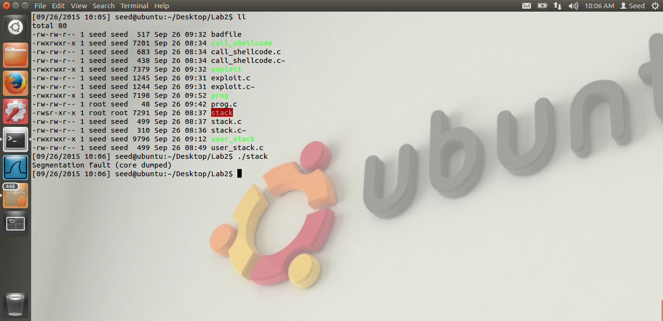

From the above screen shot, we can see that when we turn on the address randomization, we are not able to successfully attack the system.

Reason: When we turn on the address randomization, the stack could be allocated at any random address. This is unlike our first task, where the starting address is fixed. Hence we were able to calculate the return address and put the malicious code at the proper place. As we turn on the address randomization, the stack could be allocated any address. Thus, the attack will only be successful, when the system allocates the stack to the address, which comes in the range of our buffer. Thus, if the return address is in the range of our NOP instructions, our attack will be successful. Hence, when we run the command in a while loop, after lot of time, we can be successful.

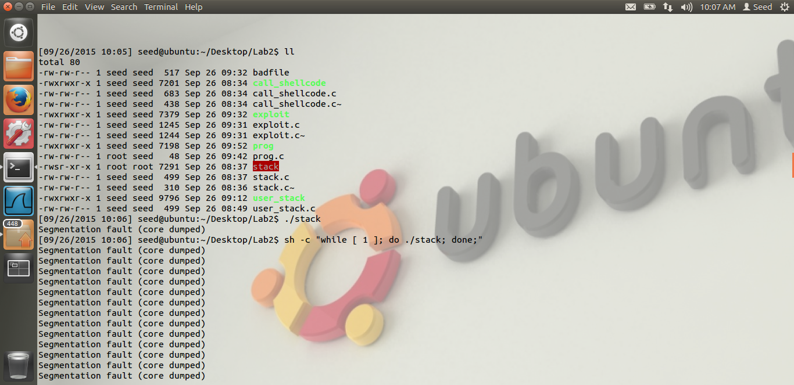

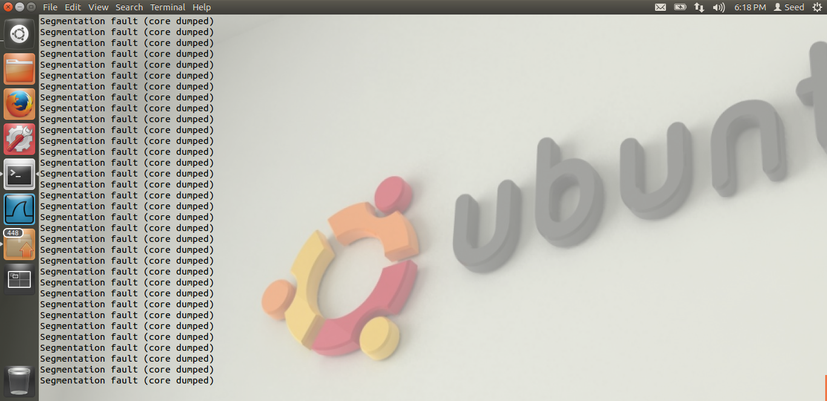

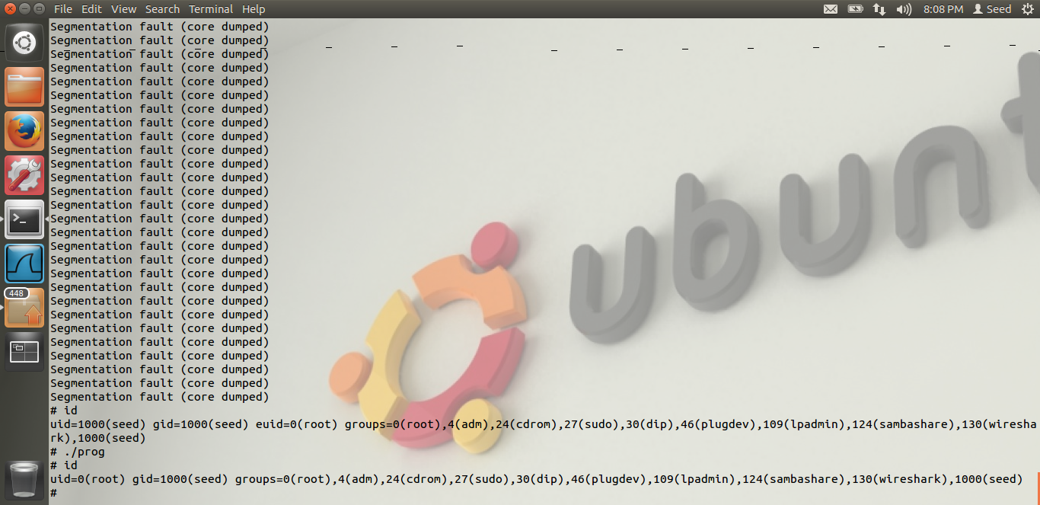

From the above screen shot, we can see that, we were able to attack the system after running in a while loop. From the id command, we could see we have got the root shell. Thus the attack was successful.

# TASK 3: STACK GUARD

The screen shot for Task-3 are below.

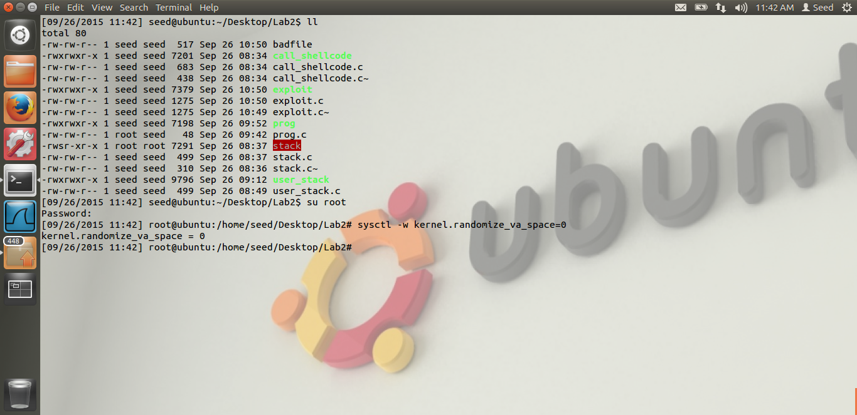

In the above screen shot, we see that, we turned off the address randomization.

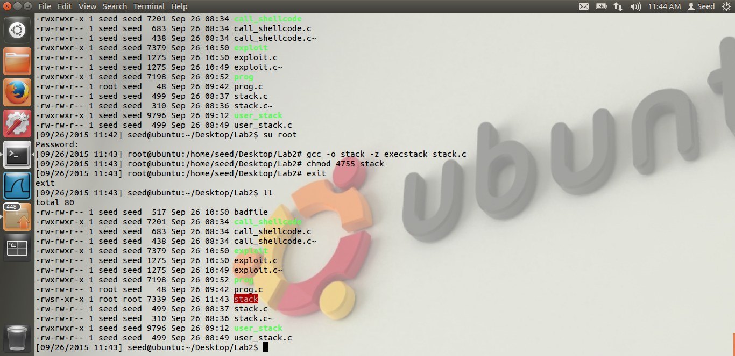

In the above screen shot, we see that, we compile the vulnerable program, without the –fno-stack-protector option. Thus, after that is done, we make it set-UID as before. Thus, our environment and vulnerable program is ready. Now, we have to execute it.

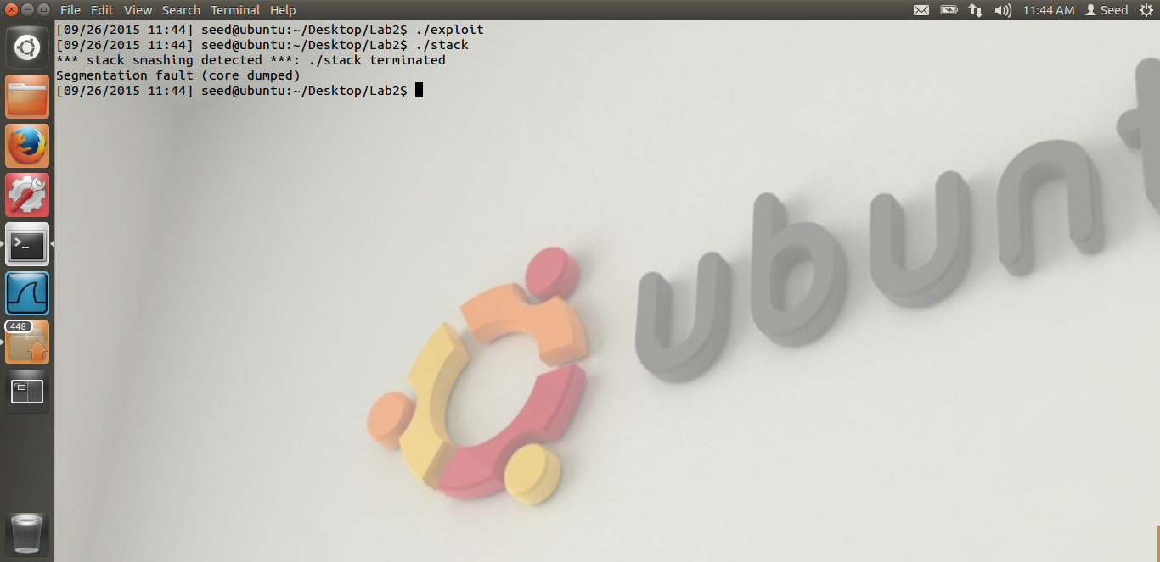

When we repeat task 1, we get the above error. From the screen shot, we see that, we get the error, “Stack smashing detected, and then our vulnerable program is terminated. Thus we are not able to attack.

Reason. The GCC, i.e. the compiler protects the stack using the stack guard protection. The stack guard protections works as follows. We(The compiler) puts a local variable in the stack, before the return address, i.e. we can put a local variable, below where the ebp is pointing. We put a random number in this variable. Thus, whenever there is a buffer overflow, we cannot overflow the return address without overflowing the local variable value. Because it is before the return address, i.e. it is stored before the return address. And we store this value in the heap. We cannot store it in stack, as stack can be overflowed. Before we return, the compiler checks this local variable value with the value stored in the heap. If it is different, then the compiler can come to know that there has been a buffer overflow attack. Thus, it will detect the stack smashing, which it shows in the output, as seen from above screen shot. If both the value are equal, that means, there has been no attack.

Thus, in the above way, the compiler executes the stack guard protection.

# TASK 4: NON- EXECUTABLE STACK

The screen shots for Task4 are below.

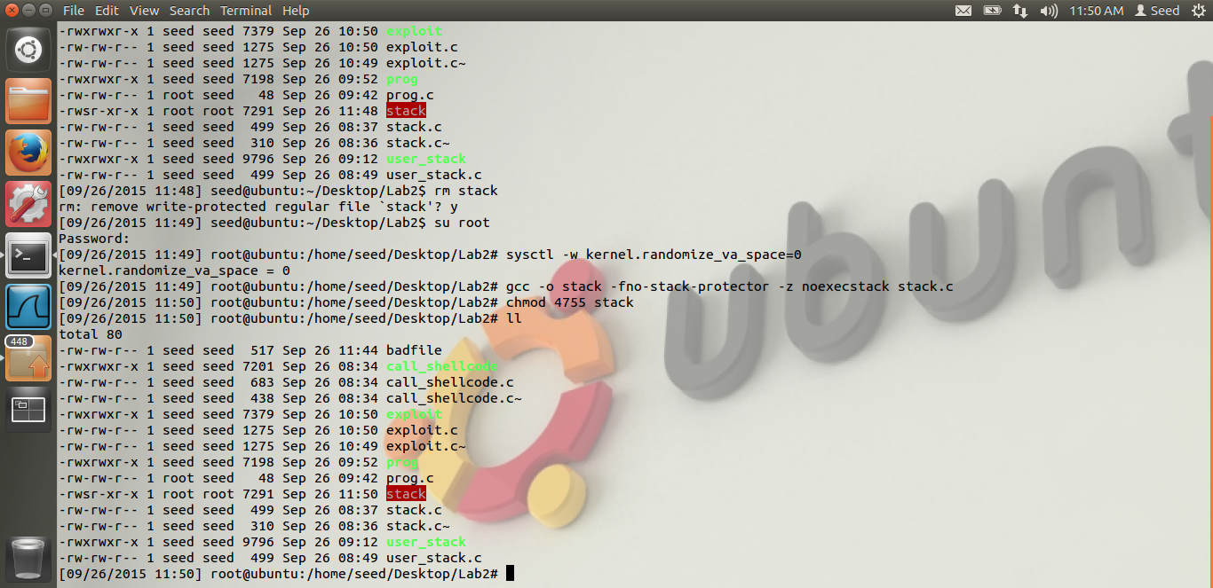

Thus, from the screen shot, we see that, we have turned off address randomization. Also, our vulnerable code is now compiled using the noexecstack option. i.e. the stack is made non executable. Thus, our environment has been set-up. We try to attack the system.

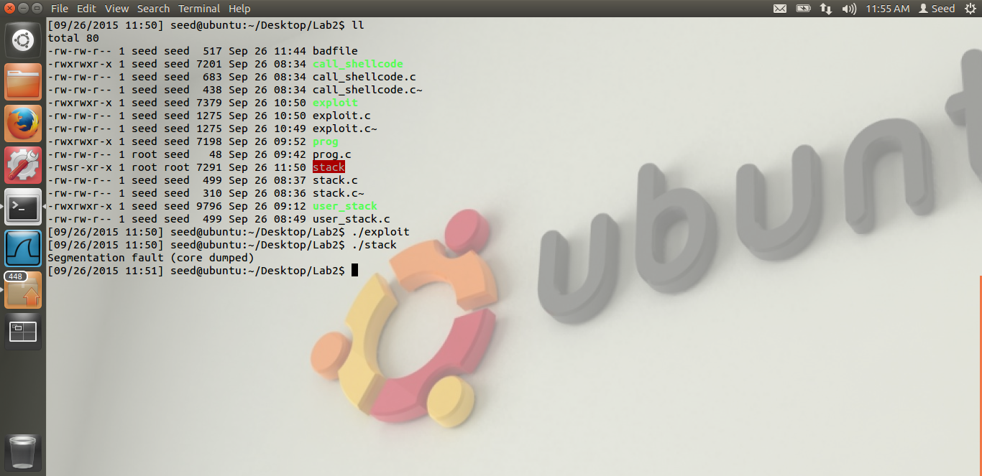

Thus, when we run the vulnerable program, we get the segmentation fault(core dumped) error. Thus our attack is not successful.

Reason: As the stack is non executable, our system detects that a code is trying to run. Hence, it knows that this part of memory is non- executable. Hence it gives segmentation fault error. Thus, non – executable stack, we were not able to attack the system. But this could be attacked via return-libc attack which we will be performing in Lab3.